Experiment-23
Aim:To write a Prolog program to represent a family tree and identify family relationships.
Algorithm:
- Start.
- Define facts for male and female family members.
- Define parent relationships between family members.
- Create a rule to identify the father using gender and parent facts.
- Create a rule to identify the mother using gender and parent facts.
- Create a rule to identify grandparents using parent relationships.
- Create a rule to identify siblings by checking whether they share a parent and are different persons.
- Load the program in SWI-Prolog.
- Enter queries to check family relationships and display the results.
- Stop.
Code:
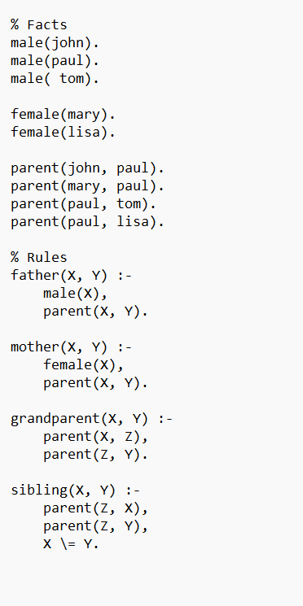

Output:
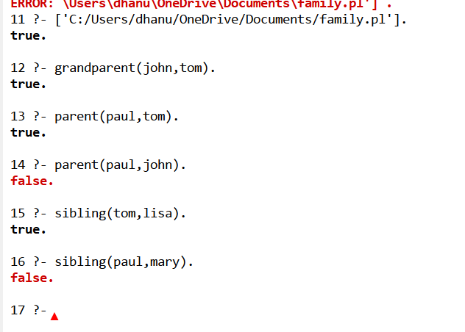
Result:
Thus the prolog program to represent a family tree and identify family relationships.

